Introduction:  
Continuous Delivery is an approach where small segments of software are pushed to  
production at regular intervals. These software segments are usually made to follow a set  
of steps defined by a continuous integration pipeline where the source code is built,  
quality checked, tested and then pushed to deployment. The integration and delivery is  
automated and usually happens with a high speed and frequency.  
In this particular use case, I have tried to build a CI/CD pipeline using Gitlab. The source  
code is taken from GitHub and after going through CI pipeline it is deployed in Netlify.  
Requirement: A front end app with source code in GitHub, A GitLab account, A Netlify  
account.  
Implementation:  
Step 1: Login to your GitLab Account and select Create Project.

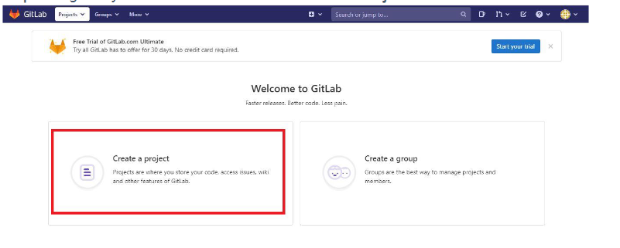

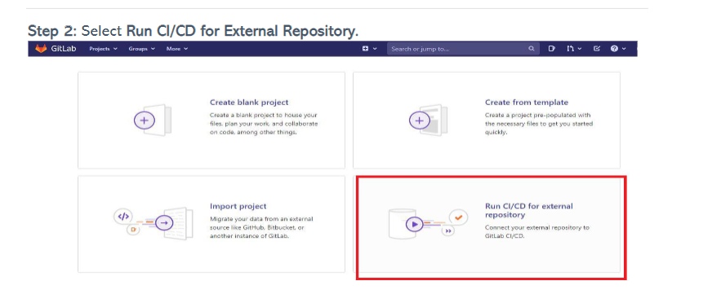

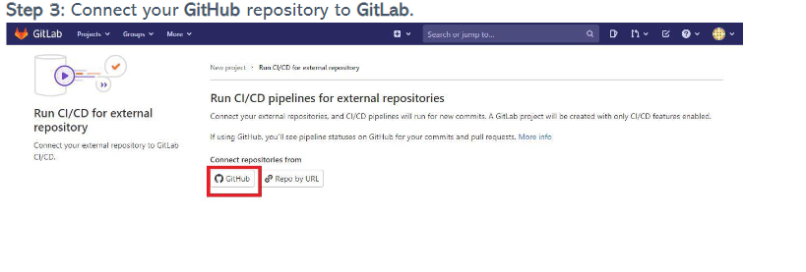

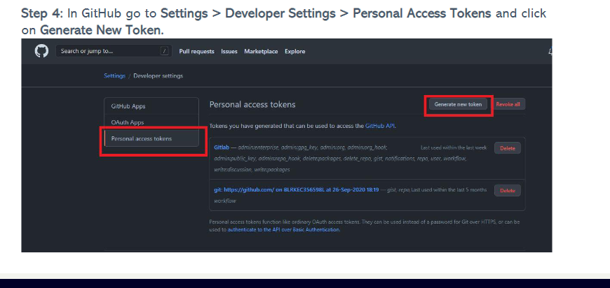

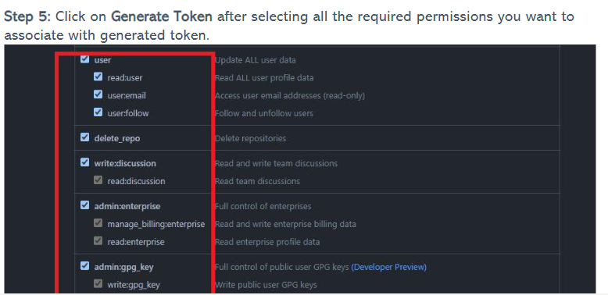

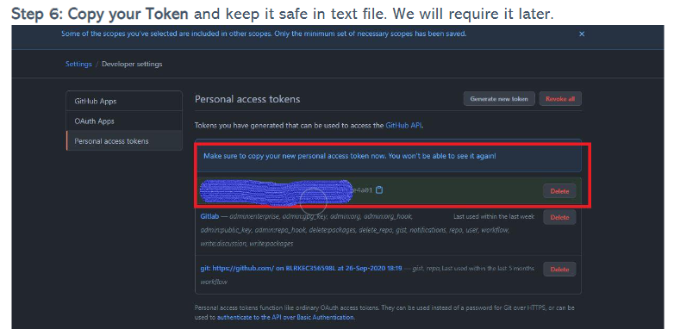

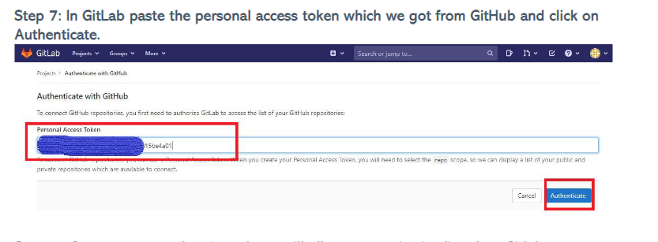

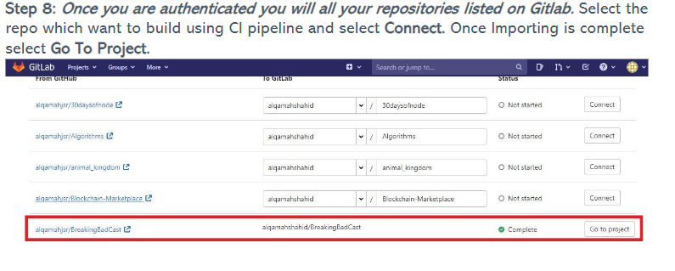

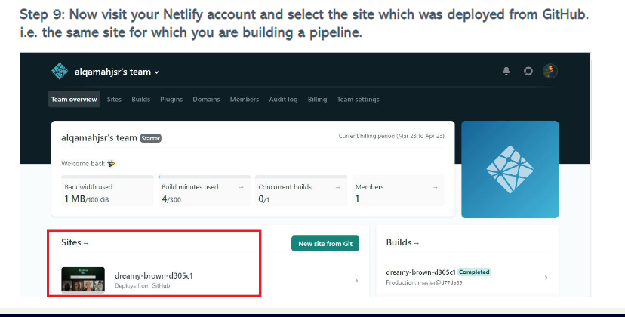

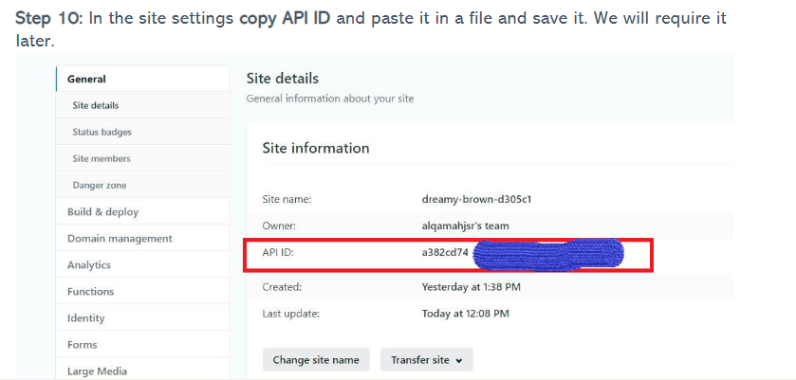

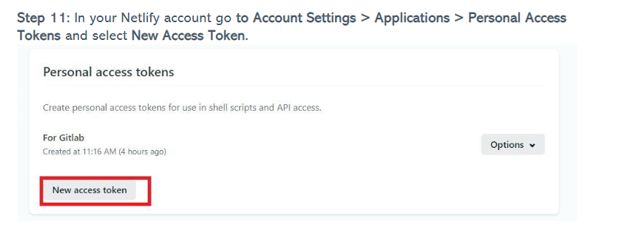

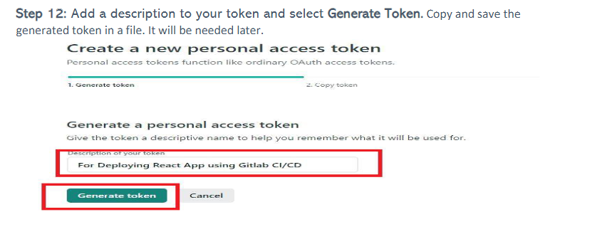

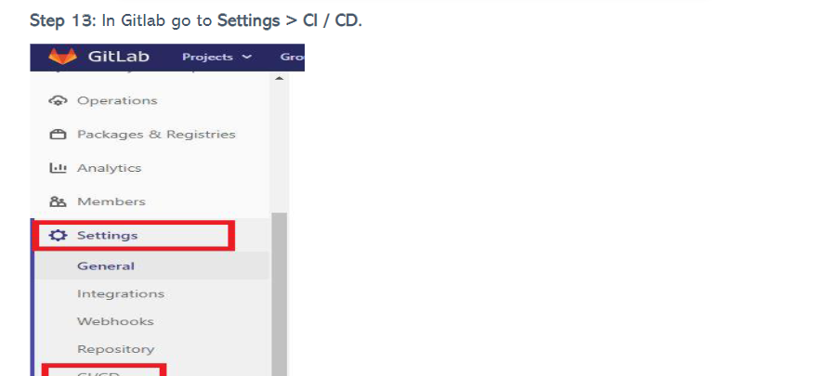

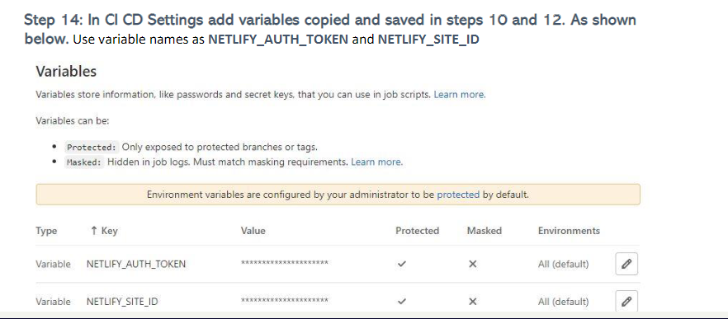

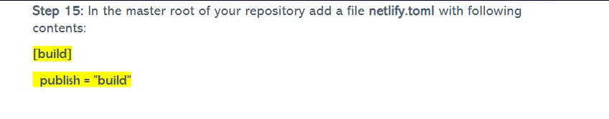

Step 16: In the master root of your repository add another file .gitlab-ci.yml with following  
contents:

